# React: Slideshow App

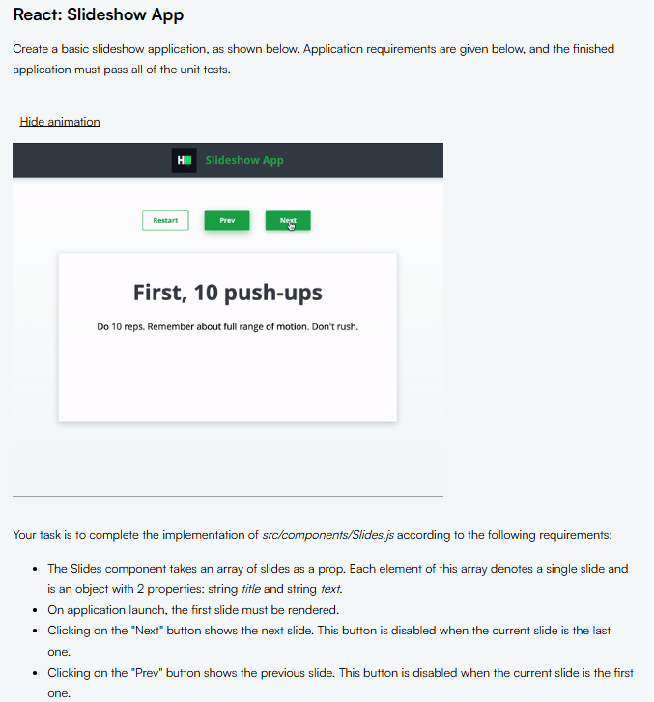

## Slides.js

import React, { useState } from 'react';

const Slides = ({slides}) => {

  const [index, setIndex] = useState(0);

  const next = () => {

    setIndex(i => i+1)

  }

  const previous = () => {

    setIndex(i => i-1)

  }

  const restart = () => {

    setIndex(0);

  }

  return (

    <div>

      <div id='navigation' className='text-center'>

        <button disabled={index === 0} onClick={() => restart()}

          data-testid='button-restart'

          className='small outlined'

        >

          Restart

        </button>

        <button disabled={index === 0} onClick={() => previous()} data-testid='button-prev' className='small'>

          Prev

        </button>

        <button disabled={index === slides.length-1} onClick={() => next()} data-testid='button-next' className='small'>

          Next

        </button>

      </div>

      <div id='slide' className='card text-center'>

        <h1 data-testid='title'> {slides[index].title}</h1>

        <p data-testid='text'> {slides[index].text}</p>

      </div>

    </div>

  );

};

export default Slides;

# React: Sorting Articles

## App.js

import React, { useState, useEffect } from 'react'

import './App.css'

import 'h8k-components'

import Articles from './components/Articles.js'

const title = 'Sorting Articles'

function App({ articles }) {

  const sortArticleByVotes = articles.sort((a, b) => b.upvotes - a.upvotes)

  const [data, setData] = useState(sortArticleByVotes)

  const sortedByVotes = () => {

    const copy = [...articles]

    const votesData = copy.sort((a, b) => b.upvotes - a.upvotes)

    setData(votesData)

  }

  const sortedByDate = () => {

    const copy = [...articles]

    const dateData = copy.sort((a, b) => (new Date(b.date) - new Date(a.date)))

    setData(dateData)

  }

  return (

    <div className='App'>

      <h8k-navbar header={title}></h8k-navbar>

      <div className='layout-row align-items-center justify-content-center my-20 navigation'>

        <label className='form-hint mb-0 text-uppercase font-weight-light'>

          Sort By

        </label>

        <button

          data-testid='most-upvoted-link'

          className='small'

          onClick={() => sortedByVotes()}>

          Most Upvoted

        </button>

        <button

          data-testid='most-recent-link'

          className='small'

          onClick={() => sortedByDate()}>

          Most Recent

        </button>

      </div>

      <Articles articles={data}/>

    </div>

  )

}

export default App

## Articles.js

import React from 'react';

const Articles = ({ articles }) => {

  return (

    <div className='card w-50 mx-auto'>

      <table>

        <thead>

          <tr>

            <th>Title</th>

            <th>Upvotes</th>

            <th>Date</th>

          </tr>

        </thead>

        <tbody>

          {articles.length > 0 &&

            articles.map((art, i) => (

              <tr data-testid='article' key={i}>

                <td data-testid='article-title'>{art.title}</td>

                <td data-testid='article-upvotes'>{art.upvotes}</td>

                <td data-testid='article-date'>{art.date}</td>

              </tr>

            ))}

        </tbody>

      </table>

    </div>

  );

};

export default Articles;